Titel: Linux Installfest Intermediate
Subtitle: Installing and updating Domino on Linux
Authors: Martijn de Jong, Bill Malchisky, Daniel Nashed
Goal for this session
Have a working HCL Domino server on Linux
Which can easily by started, stopped and show the Domino console
How to start
Log in on your personal server
Use your favourite client to open an SSH session
We recommend MobaXterm
Update your Linux installation
RedHat & clones | Ubuntu & clones
dnf -y update  (yum is RHEL 7-, but still works) | apt -y update && apt -y upgrade

Install required and optional Linux packages
RedHat & clones | Ubuntu & clones
dnf -y install tar unzip openssl git | apt -y install unzip jq git vim nano gdb-minimal
Optional:  dnf -y install sysstat bind-utils net-tools | Optional:  apt -y install sysstat dnsutils net-tools

Create a user “notes”
useradd notes -U -m
Create necessary directories
mkdir -p /local/{notesdata,translog,nif,ft,daos,software}
Make notes user owner of directories
chown -R notes:notes /local
Set security limits
vi/nano/micro /etc/security/limits.conf
notes soft nofile 80000
notes hard nofile 80000
Download the software

Go to https://my.hcltechsw.com.
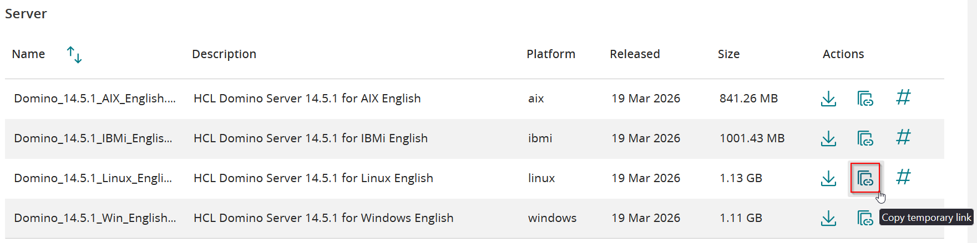
cd /local/software
curl “<temporary link>” -o <name package>
Unpack the Domino installation package
tar xf <domino package>
Ubuntu – pass os-check
export INSTALL_NO_CHECK=1
export JAVA_TOOL_OPTIONS="-Djava.awt.headless=true"
Install Domino
cd linux64
./install
Install a domino start-script
The best one around is Daniel Nashed’s startscript
cd /local/
git clone https://github.com/nashcom/domino-startscript.git
cd domino-startscript
./install_script
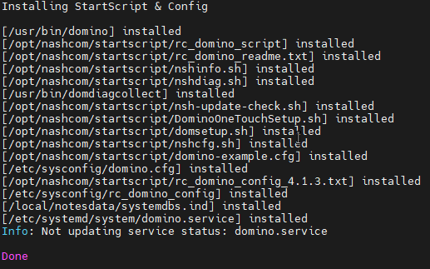
Open the firewall (RedHat & clones)
cp /local/domino-startscript/extra/firewalld/nrpc.xml /etc/firewalld/services
firewall-cmd --zone=public --permanent --add-service={nrpc,http,https,smtp}
firewall-cmd --reload
Check your exposed ports:
firewall-cmd --list-services
Setup your Domino server
domino setup
Start your Domino server
domino start
See what’s happening:
domino console
Install Nomad
Download Nomad from My HCL Software portal
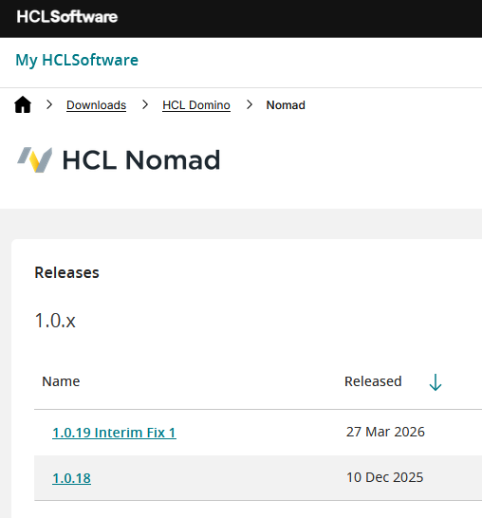
For the workshop, you can find it in /lab/software
Allow notes user to start domino through systemd
echo "%notes ALL= NOPASSWD: /usr/bin/systemctl *" >> /etc/sudoers
(this allows you to start the server from the menu that you get when you just type ‘domino’)

